NAME : BHARAT BHUSHAN SINGH DATE OF REPORT : 07/01/2026 AGE: 42 YRS/ M
Refd. By DR.: DR. K SASIKUMAR DNB ORTHO

==============================================================================REPORT OF M.R.I. DL.SPINE

Technique: Multiplanar, multisequence MRI of the Dorso lumbar spine was performed

Findings
- Lumbarisation of S1 vertebra.
- Loss of normal lumbar lordosis.
- Reduced intervertebral disc space at L5–S1.
- Disc desiccation at L5–S1.
- Mild diffuse disc bulge at L2–3, causing minimal indentation of the thecal sac.
- Diffuse disc bulge with central protrusion causing anterior thecal sac compression , and compression of bilateral traversing nerve roots and B/L neural foraminal stenosis at L5–S1.
- Modic type endplate changes involving various endplates.
LEVEL | D9-D10 | D10-D11 | D11-D12 | L1-L2 | L2-L3 | L3-L4 | L4-L5 | L5-S1
AP mm | 11.2 | 11.2 | 11.2 | 12.2 | 12.9 | 12.3 | 11.6 | 6.5
- No significant spinal canal stenosis or nerve root compression.
- Conus medullaris is normal in position and signal intensity.
- Paraspinal soft tissues appear unremarkable.
- LUMBAR CANAL AP DIAMETER AT L1 TO L5 LEVELS

Impression
- Lumbarisation of S1 vertebra.
- Loss of normal lumbar lordosis.
- Reduced intervertebral disc space at L5–S1.
- Disc desiccation at L5–S1.
- Mild diffuse disc bulge at L2–3, causing minimal indentation of the thecal sac.
- Diffuse disc bulge with central protrusion causing anterior thecal sac compression , and compression of bilateral traversing nerve roots and B/L neural foraminal stenosis at L5–S1.
- Modic type endplate changes involving various.

Correlation Advised
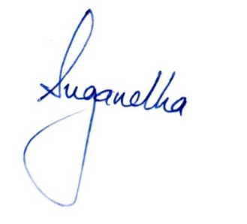
- Correlate with clinical symptoms

